ANALYSIS OF SPATIAL DISTRIBUTION AND SERVICEABILITY OF OFFICIAL POLLING STATIONS USING GIS AND WEBGIS IN NABIRE DISTRICT
Gunawan Prayitno¹, Eka Melani Majid²
¹⁾ Program Studi Informatika, Sekolah Tinggi Manajemen Informatika dan Komputer Pesat Nabire
²⁾ Program Studi Informatika, Sekolah Tinggi Manajemen Informatika dan Komputer Pesat Nabire
¹binaanakpapua@gmail.com, ²melanmajid@gmail.com
…….
ABSTRACT
Temporary waste collection sites play an important role in urban waste management. However, the spatial distribution and service coverage of official temporary waste collection sites (TPS) in Distrik Nabire have not been comprehensively evaluated. This study aims to analyze the spatial distribution and service coverage of official TPS in Distrik Nabire using a Geographic Information System (GIS) and to implement the results in an interactive WebGIS. A quantitative spatial approach was applied using official TPS point data, temporary landfill data, administrative boundary data, and GIS-based spatial processing. The analysis included mapping TPS locations, applying Nearest Neighbor Analysis (NNA) to identify the distribution pattern, generating a 500-meter buffer to measure service coverage, and overlaying the dissolved buffer with administrative boundaries to identify serviced areas more accurately. The results showed that the spatial distribution of official TPS tends to be clustered, with an NNA value of 0.7636 and a Z-score of -2.02. Only 13.14 km² of the 205.26 km² study area was covered by TPS services, representing 6.40% of the total area, while 93.60% remained outside the service range. These results indicate that the current TPS distribution is still not optimal, and WebGIS can support interactive spatial visualization for evaluation and decision-making.
Keywords: GIS, WebGIS, spatial distribution, service coverage, TPS

INTRODUCTION
The growth of urban activities has direct implications for the increase in waste generation [1]. Poorly planned waste management can cause various environmental problems, such as soil and water pollution, public health disturbances, and a decrease in the aesthetic quality of the environment. Therefore, an effective and data-based waste management system is an important need to support sustainable development [2].
One of the important components of the waste management system is the availability and distribution of Temporary Shelters (TPS). TPS functions as a waste collection point before being transported to the Final Disposal Site (TPA). Uneven distribution of TPS can lead to the accumulation of waste in certain areas, low service affordability, and increased potential for uncontrolled waste disposal [3]. Therefore, analysis of TPS distribution and serviceability is a crucial aspect in waste system planning.
Nabire District as the center of activity in Nabire Regency has relatively high socio-economic activity compared to the surrounding area. This condition has the potential to increase the volume of waste produced every day. Although the government through the Environment Agency has provided an official TPS, it is not known for sure whether the distribution of the TPS has been evenly distributed and is able to reach the needs of community waste services. In addition, there has been no spatial study that specifically analyzes the affordability of TPS to residential areas in Nabire District
Based on these problems, this study aims to analyze the spatial distribution and level of official TPS serviceability in Nabire District using the Geographic Information System approach. The analysis was carried out through TPS distribution mapping, the application of Nearest Neighbor Analysis to identify distribution patterns, the creation of a 500-meter radius buffer to measure service coverage, and spatial overlays to identify the areas served more accurately [4]. The results of the analysis were then implemented in the form of WebGIS to support interactive visualization of TPS distribution and serviceability [5]. With this approach, this study is expected to provide a comprehensive spatial overview of the distribution and serviceability conditions of TPS in Nabire District and become a basis for consideration in planning waste management that is more effective, efficient, and based on spatial data.

LITERATURE REVIEW
Geographic Information Systems (GIS) have an important role as a tool for analyzing and visualizing location-based data [6]. GIS allows integration between spatial data, such as TPS locations, regional boundaries, and road networks, with non-spatial data, such as waste volume and TPS capacity, so that it can produce more comprehensive information. In this study, GIS is used as a basis for analyzing the distribution of waste facilities and evaluating the spatial serviceability of the area [7].
One of the analysis methods used in GIS is buffer analysis, which is the creation of zones with a certain radius of a point to measure the service coverage to the surrounding area. In the context of this study, buffer is used to determine the coverage of official TPS services for residential areas in Nabire District. In addition, overlay analysis is used to combine various spatial layers so that it can help identify areas that are within the range of TPS services more accurately.
To analyze the distribution pattern of polling stations, this study uses Nearest Neighbor Analysis (NNA). This method is used to find out whether the distribution of facility points tends to be clustered, random, or evenly distributed. Through this analysis, the distribution pattern of polling stations can be identified quantitatively so that the results of the study do not only depend on the visual interpretation of the map.
A number of previous studies have utilized Geographic Information Systems in the management of public facilities and urban infrastructure, including waste management. The results of these studies show that the GIS approach can be used to map the location of waste facilities, evaluate their distribution, and support spatial-based service analysis. Some studies emphasize more on equitable distribution of facilities, mapping the locations of official and illegal polling stations, comparing the capacity of polling stations with waste generation, or evaluating the distribution patterns of waste facilities in various urban areas.
On the other hand, there are also studies that develop WebGIS applications to support location-based waste management, but focus more on system development and data visualization without in-depth spatial analysis of TPS distribution and serviceability. Based on these conditions, it can be seen that the integration between official TPS distribution analysis, serviceability measurement using standardized radius buffers, and the implementation of analysis results in the form of WebGIS at the administrative district scale is still limited, especially in the context of Nabire District. Therefore, this study positions itself as a development of previous studies by combining spatial distribution analysis, serviceability evaluation, and WebGIS implementation in one research framework.

RESEARCH METHODS
  - Data Collection and Processing
This study uses a quantitative approach with spatial analysis based on Geographic Information System (GIS) [6]. The research location is in Nabire District, Nabire Regency, with the object of the research in the form of an official Temporary Shelter (TPS) registered with the Environment Agency [8]. The data used consists of spatial data in the form of TPS locations, landfill locations, and administrative area boundaries, as well as non-spatial data in the form of information on waste volume and TPS capacity [9].
Data collection was carried out through literature study and documentation of official TPS data [10]. Spatial data was then processed using GIS software through the process of data input of TPS points, integration of administrative boundaries, and the incorporation of supporting attributes at each TPS point [11].
  - Distribution and Service Analysis of TPS
The analysis of the distribution of polling stations was carried out through mapping the distribution of polling stations and Nearest Neighbor Analysis (NNA) to identify spatial distribution patterns [8]. The index value of the nearest neighbors was used to determine whether the distribution pattern of polling stations tended to be clustered, random, or evenly distributed [12].
The service analysis was carried out by creating a buffer radius of 500 meters at each TPS point to measure the service coverage to the surrounding area [13]. All buffers were then combined using a dissolve process to avoid double calculations on overlapping areas [14]. Furthermore, an overlay was carried out between the buffer of the dissolved results and the boundaries of the village administrative area to identify the areas served more accurately [10].

3.3 WebGIS Implementation
The final stage of the research is the implementation of the analysis results into the form of interactive WebGIS based on HTML, CSS, JavaScript, and Leaflet.js [15]. The spatial data from GIS processing is exported into GeoJSON format so that it can be dynamically visualized through WebGIS [14]. The research flow chart is used to illustrate all stages of research from problem identification to conclusion drawn.
The research flow diagram describes the stages of research ranging from problem identification and literature study, data collection, spatial data processing, TPS distribution analysis, TPS serviceability analysis using a 500-meter buffer, overlay analysis of the served area, implementation of WebGIS, to conclusion drawing [15]. The research flow diagram can be seen at Figure 1.

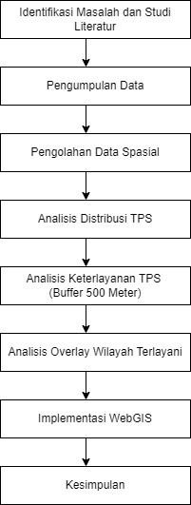
Figure 1. Research Flow Diagram

RESULTS AND DISCUSSION
Official TPS Spatial Distribution
The mapping results showed that the distribution of official Temporary Shelters (TPS) in Nabire District was not even in all study areas [8]. Visually, TPS points tended to be concentrated in certain areas, especially in areas with relatively higher community activities, while some other parts of the region still did not have adequate TPS facility support. This condition shows the inequality of distribution of waste facilities between regions.
To strengthen the visual analysis, Nearest Neighbor Analysis (NNA) was conducted to identify the pattern of TPS distribution quantitatively [16]. The results of the analysis showed that the nearest neighbor index (R) value was 0.7636 with a Z-score of -2.02. An R value of less than 1 indicates that the distribution pattern of official polling stations in Nabire District tends to be clustered, while a negative Z-score reinforces that the grouping pattern is statistically quite real.
These findings show that the placement of official TPS is still focused on certain areas and has not been spread proportionally to all study areas. The distribution pattern that groups has implications for the formation of service concentrations only around certain points, so that some other areas have the potential to not have optimal access to waste services [9]. Thus, the results of the spatial distribution analysis show that the distribution of existing TPS is still uneven and needs to be a concern in the evaluation of waste services in Nabire District.

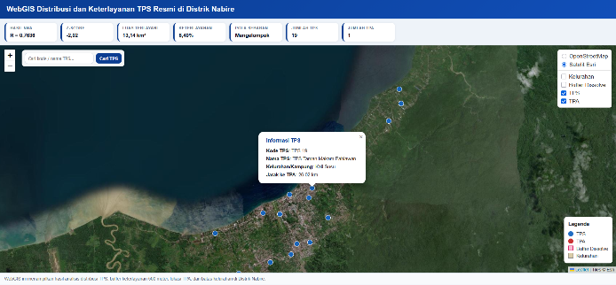
Figure 2. Spatial Distribution of Official TPS in Nabire District

TPS Serviceability Based on 500 Meter Buffer
The service analysis was carried out using a buffer radius of 500 meters from each TPS point to measure the service coverage to the surrounding area [17]. At the processing stage, all buffers are combined using a dissolve process so that overlapping areas are not calculated repeatedly [18]. This step is important to produce a more accurate area of the served area and represent the total service coverage of the entire TPS.
The results of the analysis show that the area served by the official polling station in Nabire District is only 13.14 km² out of the total study area of 205.26 km². Thus, the percentage of areas that are within the service range of the polling station is only around 6.40%, while around 93.60% of the other areas are still outside the service range. These findings show that the level of official polling station service in Nabire District is still low.
The low level of serviceability indicates that the distribution of TPS has not been optimal in reaching all residential areas. People who are outside the 500-meter buffer range have the potential to travel longer distances to dispose of waste. This condition can reduce the effectiveness of waste services and in the long term has the potential to trigger uncontrolled waste disposal practices [19]. In the context of urban infrastructure services, facilities such as TPS should be placed with coverage distances in mind so that they can be accessed more fairly and efficiently by the community.
Spatially, the low coverage of this service also strengthens the results of previous distribution analysis which shows that the distribution pattern of polling stations tends to be clustered. When polling stations are concentrated in certain areas, the service areas formed are only dominant in zones adjacent to the location of the polling stations, while other areas remain unreached. This shows that the main problem in this study is not only the number of polling stations, but also the unbalanced placement pattern between regions.
With service coverage only reaching 6.40%, it can be concluded that the need for additional TPS in Nabire District is still relatively high. Areas that are outside the 500-meter buffer range need to be prioritized in planning the placement of new TPS. Through this approach, the management of waste facilities can be improved not only in terms of quantity, but also in terms of equitable distribution of service access spatially.
In addition, the use of spatial analysis in this study provides a more objective approach in identifying areas that have been and have not been served. The Geographic Information System-based approach allows serviceability evaluation to be carried out in a measurable manner through the integration of data on the location of polling stations, service coverage areas, and administrative boundaries [20]. Thus, the results of the study are not only descriptive, but can also support spatial data-based decision-making.

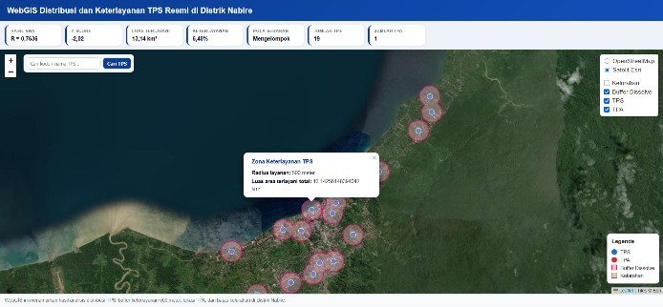
Figure 3. TPS Serviceability Based on 500 Meter Buffer
Table 1. Results of TPS Service Analysis in Nabire District
No | Indikator | Value
1 | Area of study | 205,26 km²
2 | Area served | 13,14 km²
3 | Percentage of areas served | 6,40%
4 | Percentage of unserved territories | 93,60%

WebGIS Implementation
The results of the spatial analysis were then implemented in the form of interactive WebGIS as a medium for visualization and presentation of information [15]. This implementation provides added value because the results of the distribution of polling stations, landfill locations, 500-meter service buffers, and administrative area boundaries can be displayed in an integrated manner in one platform that is easier for users to understand [14].
The WebGIS developed displays several main layers, namely the location of the polling station, the 500-meter service buffer, the location of the landfill, and the boundaries of the village [21]. This system is also equipped with information popups, control layers, basemap options, polling station search features, and map legends. With these features, the results of the analysis of the distribution and serviceability of the polling stations are not only presented in the form of static maps, but can also be explored in a more interactive manner.
In the context of this study, the implementation of WebGIS shows that GIS-based spatial analysis can be further developed into a communicative and applicative information system. Thus, the research does not stop at the stage of identifying distribution patterns and the serviceability of TPS, but also produces information presentation media that can be used to support the evaluation and planning of waste facilities in Nabire District.

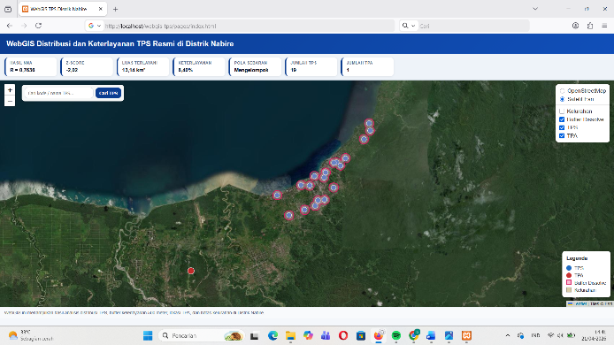
Figure 4. Implementation of WebGIS Distribution and Service of TPS in Nabire District

CONCLUSION

Conclusion
Based on the results of the analysis that has been carried out, it can be concluded that the spatial distribution of official polling stations in Nabire District tends to be clustered, which is shown by the Nearest Neighbor Analysis (NNA) value of 0.7636 with a Z-score of -2.02. These results show that the distribution of polling stations is not even in all study areas.
A service analysis using a 500-meter radius buffer showed that the area served by the official TPS was only 13.14 km² out of the total study area of 205.26 km², or around 6.40%, while the other 93.60% of the area was still outside the service range. This condition shows that the level of service of the official TPS in Nabire District is still low and has not been optimal in reaching all residential areas.
The results of the spatial analysis were subsequently successfully implemented in the form of interactive WebGIS which displays the TPS location layer, landfill location, service buffer, and administrative area boundaries. This implementation shows that GIS and WebGIS can be used not only to analyze the distribution and serviceability of TPS, but also to present the results of the analysis in a more communicative and interactive manner to support evaluation and decision-making.

Suggestions
Based on the results of the research that has been conducted, there are several suggestions that can be proposed. First, it is necessary to add new TPS points in areas that are still beyond the service range so that the level of waste serviceability in Nabire District can increase. Second, further research can use additional data such as road networks, waste generation, or regional socio-economic data so that the analysis of serviceability becomes more detailed. Third, the WebGIS that has been developed can be improved by adding advanced analysis features, periodic data updates, and integration with waste management operational data so that it can be used more optimally by related parties.

BIBLIOGRAPHY

[1] J. A. Araiza-Aguilar, M. N. Rojas-Valencia, H. A. Nájera-Aguilar, R. F. Gutiérrez-Hernández, and C. M. Garc\’\ia-Lara, “Using spatial analysis to design a solid waste collection system,” Urban Sci., vol. 8, no. 3, p. 95, 2024.
[2] P. R. Bahari, Y. Antomi, I. Dewata, and N. Syah, “Planning a waste management system by utilizing geographic information systems,” J. Penelit. Pendidik. IPA, vol. 11, no. 8, pp. 867–878, 2025.
[3] C. Huang, Y. Feng, Y. Wei, D. Sun, X. Li, and F. Zhong, “Assessing regional public service facility accessibility using multisource geospatial data: A case study of underdeveloped areas in China,” Remote Sens., vol. 16, no. 2, p. 409, 2024.
[4] F. Adibah, D. C. Saputra, H. H. Sugasta, A. D. Parabi, and D. P. Santosa, “Evaluation of Circular Buffer and Service Area Buffer Methods in Accessibility Analysis of Trans Metro Bandung Route 1 Based on GIS,” J. Tek. Sipil, vol. 25, no. 4, pp. 2385–2398.
[5] M. Ardianti, S. Suakanto, and R. Z. Zulkarnaen, “Development of Waste Management Application using GIS,” Sist. J. Sist. Inf., vol. 14, no. 6, pp. 3020–3027, 2025.
[6] J. Wang, Y. Shi, Z. Qin, Y. Chen, and Z. Cao, “A Three-Dimensional Buffer Analysis Method Based on the 3D Discrete Global Grid System,” ISPRS Int. J. Geo-Information, vol. 10, no. 8, p. 520, 2021.
[7] T. Kawasaki, H. Saito, and K. Tanaka, “Optimizing the number and location of household waste collection sites by multi-maximal covering location model: An empirical study,” J. Clean. Prod., vol. 379, p. 134644, 2022.
[8] V. Arsanti et al., “Spatial Analysis of Waste Management Facility Distribution Using GIS,” Adv. Sustain. Sci. Eng. Technol., vol. 6, no. 4, p. 2404013, 2024.
[9] Y. Ding, J. Zhao, J. Liu, and others, “A review of China’s municipal solid waste (MSW) and comparison with international regions: Management and technologies in treatment and resource utilization,” J. Clean. Prod., vol. 293, p. 126144, 2021, doi: 10.1016/j.jclepro.2021.126144.
[10] M. Hidayat, Maryono, Widjonarko, M. D. Taqyuddin, and P. Saraswati, “Evaluation of Rural Urban Waste Management: Integrating Logic Model and GIS Approach in Pemalang, Central Java, Indonesia,” J. Ilmu Lingkung., vol. 22, no. 3, 2024.
[11] A. Singh, “Sustainable Waste Management Through Systems Engineering Models and Remote Sensing Approaches,” SN Appl. Sci., 2022, doi: 10.1007/s43615-022-00151-3.
[12] N. Sillero, “A Simple Spatial Method for Identifying Point Clusters by Neighbourhood Relationships,” Ecologies, vol. 2, no. 3, pp. 305–312, 2021, doi: 10.3390/ecologies2030017.
[13] M. Chaerul, M. Puturuhu, and I. Artika, “Optimasi Rute Pengangkutan Sampah dengan Menggunakan Metode Nearest Neighbour (Studi Kasus: Kabupaten Manokwari),” J. Wil. dan Lingkung., vol. 10, no. 1, pp. 55–68, 2022, doi: 10.14710/jwl.10.1.55-68.
[14] M. Schiavina, M. Melchiorri, and S. Freire, “A smart and flexible approach for aggregation of adjacent polygons to meet a minimum target area or attribute value,” Sci. Rep., vol. 13, p. 4367, 2023, doi: 10.1038/s41598-023-31253-z.
[15] L. Duarte, A. C. Teodoro, M. Lobo, J. Viana, V. Pinheiro, and A. Freitas, “An Open Source GIS Application for Spatial Assessment of Health Care Quality Indicators,” ISPRS Int. J. Geo-Information, vol. 10, no. 4, p. 264, 2021, doi: 10.3390/ijgi10040264.
[16] P. Moutafis, G. Mavrommatis, M. Vassilakopoulos, and A. Corral, “Efficient Group K Nearest-Neighbor Spatial Query Processing in Apache Spark,” ISPRS Int. J. Geo-Information, vol. 10, no. 11, p. 763, 2021, doi: 10.3390/ijgi10110763.
[17] A. Majid, E. Novita, I. Gusniani, and D. M. Hartono, “Mapping of solid waste generation and collection by using GIS: A case study in Depok City,” in IOP Conference Series: Earth and Environmental Science, 2021, p. 12024. doi: 10.1088/1755-1315/716/1/012024.
[18] P. Flisek and E. Lewandowicz, “A Methodology for Generating Service Areas That Accounts for Linear Barriers,” ISPRS Int. J. Geo-Information, vol. 8, no. 9, p. 423, 2019, doi: 10.3390/ijgi8090423.
[19] L. Graham, M. Patel, and S. Huang, “Service accessibility and waste disposal behaviour: implications for equitable waste management,” Resour. Conserv. Recycl., vol. 170, p. 105600, 2021, doi: 10.1016/j.resconrec.2021.105600.
[20] P. Oliveira, J. Mendes, and L. Costa, “Integrating spatial and non-spatial data for service coverage assessment using GIS,” Sustainability, vol. 12, no. 7, p. 2801, 2020, doi: 10.3390/su12072801.
[21] R. Netek, J. Masopust, F. Pavlicek, and V. Pechanec, “Performance Testing on Vector vs. Raster Map Tiles—Comparative Study on Load Metrics,” ISPRS Int. J. Geo-Information, vol. 9, no. 2, p. 101, 2020, doi: 10.3390/ijgi9020101.

